NETWORK SIMULATOR 2

EX.NO:1 Generating network topology using NS2

AIM:

To write a tcl script to create a simple topology in NS2.

EXPLANATION:

A simple topology of four nodes are created. A duplex link is established between the node n0 and n1, n0 and n2 and n0 and n3.

PROGRAM:

set ns [new Simulator]

**#create file for analysis mode**

set tr [open out.tr w]

$ns trace-all $tr

**#create file for Animation Mode**

set namtr [open out.nam w]

$ns namtrace-all $namtr

**#Create Node**

set n0 [$ns node]

set n1 [$ns node]

set n2 [$ns node]

set n3 [$ns node]

**#Create Link**

$ns duplex-link $n0 $n1 10Mb 5ms DropTail

$ns duplex-link $n2 $n0 10Mb 5ms DropTail

$ns duplex-link $n3 $n0 10mb 5ms DropTail

**#Create Orientation**

$ns duplex-link-op $n0 $n1 orient right

$ns duplex-link-op $n0 $n2 orient left-up

$ns duplex-link-op $n0 $n3 orient left-down

$ns at 10.0 "$ns halt"

$ns run

OUTPUT:

N1

N0

N3

N2

EX.2 CREATE UDP DATA TRAFFIC

AIM:

To create a UDP traffic between two nodes in a given scenario.

EXPLANATION:

A simple topology of four nodes is created. A duplex link is established between the node n0 and n2, n1 and n2 and n2 and n3. UDP CBR traffic is created between the nodes n1 and n3 and another CBR traffic between n2 and n3.

PROGRAM:

set ns [new Simulator]

set nf [open out.nam w]

$ns namtrace-all $nf

proc finish {} {

global ns nf

$ns flush-trace

close $nf

exec nam out.nam &

exit 0

}

set n0 [$ns node]

set n1 [$ns node]

set n2 [$ns node]

set n3 [$ns node]

$ns duplex-link $n0 $n2 1Mb 10ms DropTail

$ns duplex-link $n1 $n2 1Mb 10ms DropTail

$ns duplex-link $n3 $n2 1Mb 10ms DropTail

$ns duplex-link-op $n0 $n2 orient right-down

$ns duplex-link-op $n1 $n2 orient right-up

$ns duplex-link-op $n2 $n3 orient right

#Create a UDP agent and attach it to node n0

set udp0 [new Agent/UDP]

$ns attach-agent $n0 $udp0

# Create a CBR traffic source and attach it to udp0

set cbr0 [new Application/Traffic/CBR]

$cbr0 set packetSize_ 500

$cbr0 set interval_ 0.005

$cbr0 attach-agent $udp0

#Create a UDP agent and attach it to node n1

set udp1 [new Agent/UDP]

$ns attach-agent $n1 $udp1

# Create a CBR traffic source and attach it to udp1

set cbr1 [new Application/Traffic/CBR]

$cbr1 set packetSize_ 500

$cbr1 set interval_ 0.005

$cbr1 attach-agent $udp1

set null0 [new Agent/Null]

$ns attach-agent $n3 $null0

$ns connect $udp0 $null0

$ns connect $udp1 $null0

$ns at 0.5 "$cbr0 start"

$ns at 1.0 "$cbr1 start"

$ns at 4.0 "$cbr1 stop"

$ns at 4.5 "$cbr0 stop"

$udp0 set class_ 1

$udp1 set class_ 2

$ns color 1 Blue

$ns color 2 Red

$ns duplex-link-op $n2 $n3 queuePos 0.5

$ns duplex-link $n3 $n2 1Mb 10ms SFQ

$ns at 5.0 "finish"

$ns run

OUTPUT:

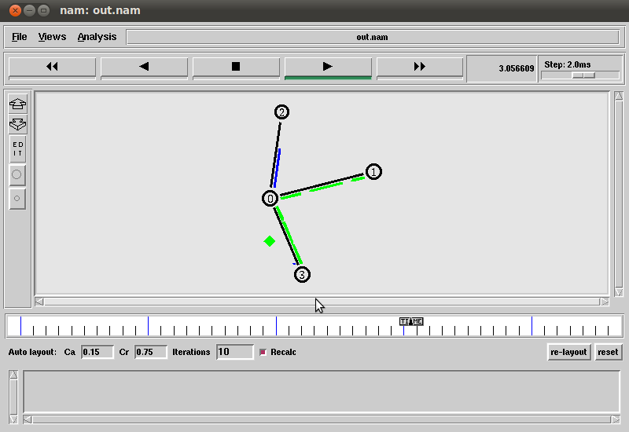

EX.3 TCP DATA TRAFFIC

AIM:

To create tcp data traffic between two nodes in a given scenario.

EXPLANATION:

A simple topology of four nodes is created. A duplex link is established between the node n0 and n2, n1 and n2 and n2 and n3. TCP FTP traffic is created between the nodes n1 and n3 and another TCP traffic between n2 and n3.

PROGRAM:

set ns [new Simulator]

set nf [open out.nam w]

$ns namtrace-all $nf

proc finish {} {

global ns nf

$ns flush-trace

close $nf

exec nam out.nam &

exit 0

}

set n0 [$ns node]

set n1 [$ns node]

set n2 [$ns node]

set n3 [$ns node]

$ns duplex-link $n0 $n1 1Mb 10ms DropTail

$ns duplex-link $n0 $n2 1Mb 10ms DropTail

$ns duplex-link $n0 $n3 1Mb 10ms DropTail

#create a tcp connection and attach to node n1

set tcp1 [new Agent/TCP]

$ns attach-agent $n1 $tcp1

$tcp1 set window_ 8

$tcp1 set fid_ 1

#create a tcp connection and attach to node n2

set tcp2 [new Agent/TCP]

$ns attach-agent $n2 $tcp2

$tcp2 set window_ 8

$tcp2 set fid_ 2

#create the sink nodes 1 and 2

set sink1 [new Agent/TCPSink]

set sink2 [new Agent/TCPSink]

#attach sink 1 and 2 to node n3

$ns attach-agent $n3 $sink1

$ns attach-agent $n3 $sink2

$ns connect $tcp1 $sink1

$ns connect $tcp2 $sink2

#Create FTP applications and attach them to agents

set ftp1 [new Application/FTP]

$ftp1 attach-agent $tcp1

set ftp2 [new Application/FTP]

$ftp2 attach-agent $tcp2

$ns at 0.1 "$ftp1 start"

$ns at 0.5 "$ftp2 start"

$ns at 3.5 "$ftp1 stop"

$ns at 5.0 "$ftp2 stop"

$ftp1 set class_ 1

$ftp2 set class_ 2

$ns color 1 Red

$ns color 2 Blue

$ns at 5.0 "finish"

$ns run

OUTPUT:

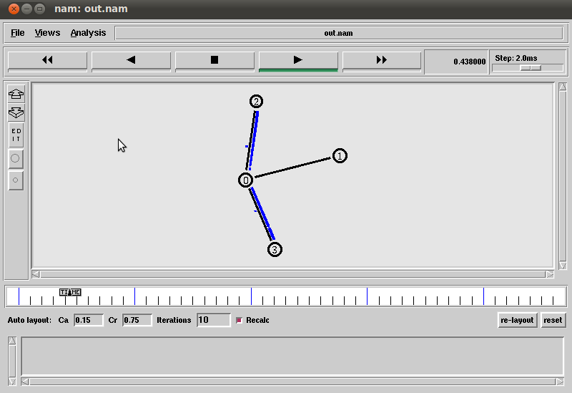

EX.3 WIRELESS SCENARIO

AIM:

To create a simple wireless scenario in NS2

EXPLANATION:

A simple topology of three nodes is created. UDP CBR traffic is created between the nodes n1 and n0 and another CBR traffic between n2 and n1.

PROGRAM:

# Define options

# ======================================================================

set val(chan) Channel/WirelessChannel ;# channel type

set val(prop) Propagation/TwoRayGround ;# radio-propagation model

set val(netif) Phy/WirelessPhy ;# network interface type

set val(mac) Mac/802_11 ;# MAC type

set val(ifq) Queue/DropTail/PriQueue ;# interface queue type

set val(ll) LL ;# link layer type

set val(ant) Antenna/OmniAntenna ;# antenna model

set val(x) 1000 ;# X dimension of topology

set val(y) 1000 ;# Y dimension of topology

set val(cp) "" ;# node movement model file

set val(sc) "" ;# traffic model file

set val(ifqlen) 50 ;# max packet in ifq

set val(nn) 3 ;# number of mobilenodes

set val(seed) 0.0

set val(stop) 1000.0 ;# simulation time

set val(tr) hidden-out.tr ;# trace file name

set val(rp) DSDV ;# routing protocol

set AgentTrace ON

set RouterTrace ON

set MacTrace OFF

# Open trace file

$ns_ use-newtrace ;# Use new trace format

set namfd [open hidden-out.nam w]

$ns_ namtrace-all-wireless $namfd $val(x) $val(y)

set tracefd [open $val(tr) w]

$ns_ trace-all $tracefd

# set up topography object

set topo [new Topography]

$topo load_flatgrid $val(x) $val(y)

# create channel

set chan [new $val(chan)]

# Create God

set god_ [create-god $val(nn)]

# Create the specified number of mobile nodes [$val(nn)] and "attach" them

# to the channel. Three nodes are created : node(0), node(1) and node(2)

$ns_ node-config -adhocRouting $val(rp) \

-llType $val(ll) \

-macType $val(mac) \

-ifqType $val(ifq) \

-ifqLen $val(ifqlen) \

-antType $val(ant) \

-propType $val(prop) \

-phyType $val(netif) \

-channel $chan \

-topoInstance $topo \

-agentTrace ON \

-routerTrace ON \

-macTrace OFF \

-movementTrace OFF

for {set i 0} {$i < $val(nn) } {incr i} {

set node_($i) [$ns_ node]

$node_($i) random-motion 0 ;# disable random motion

}

# Provide initial (X,Y, for now Z=0) co-ordinates for mobilenodes

#

$node_(0) set X_ 250.0

$node_(0) set Y_ 500.0

$node_(0) set Z_ 0.0

$node_(1) set X_ 500.0

$node_(1) set Y_ 500.0

$node_(1) set Z_ 0.0

$node_(2) set X_ 750.0

$node_(2) set Y_ 500.0

$node_(2) set Z_ 0.0

# Load the god object with shortest hop information

#

$god_ set-dist 1 2 1

$god_ set-dist 0 2 2

$god_ set-dist 0 1 1

# Now produce some simple node movements

# Node_(1) starts to move upward and then downward

set god_ [God instance]

# Setup traffic flow between nodes 0 connecting to 1 at time 100.0

set udp_(0) [new Agent/UDP]

$udp_(0) set fid_ 1

$ns_ attach-agent $node_(0) $udp_(0)

set udp_(1) [new Agent/UDP]

$udp_(1) set fid_ 2

$ns_ attach-agent $node_(2) $udp_(1)

set null_(0) [new Agent/Null]

$ns_ attach-agent $node_(1) $null_(0)

set cbr_(0) [new Application/Traffic/CBR]

$cbr_(0) set packetSize_ 500

$cbr_(0) set set interval_ 0.005

$cbr_(0) set maxpkts_ 10000

$cbr_(0) attach-agent $udp_(0)

set cbr_(1) [new Application/Traffic/CBR]

$cbr_(1) set packetSize_ 500

$cbr_(1) set set interval_ 0.005

$cbr_(1) set maxpkts_ 10000

$cbr_(1) attach-agent $udp_(1)

$ns_ connect $udp_(0) $null_(0)

$ns_ at 100.0 "$cbr_(0) start"

$ns_ connect $udp_(1) $null_(0)

$ns_ at 100.0 "$cbr_(1) start"

#Define node initial position in nam, only fro nam

for {set i 0} {$i < $val(nn)} {incr i} {

# The function must be called after mobility model is defined.

$ns_ initial_node_pos $node_($i) 60

}

# Tell nodes when the simulation ends

for {set i 0} {$i < $val(nn) } {incr i} {

$ns_ at $val(stop) "$node_($i) reset";

}

$ns_ at $val(stop) "stop"

$ns_ at $val(stop) "puts \"NS EXITING...\" ; $ns_ halt"

proc stop {} {

global ns_ tracefd namfd

$ns_ flush-trace

close $tracefd

close $namfd

exec nam hidden-out.nam &

exit 0

}

puts $tracefd "M 0.0 nn $val(nn) x $val(x) y $val(y) rp $val(rp)"

puts $tracefd "M 0.0 sc $val(sc) cp $val(cp) seed $val(seed)"

puts $tracefd "M 0.0 prop $val(prop) ant $val(ant)"

puts "Starting Simulation..."

$ns_ run

OUTPUT:

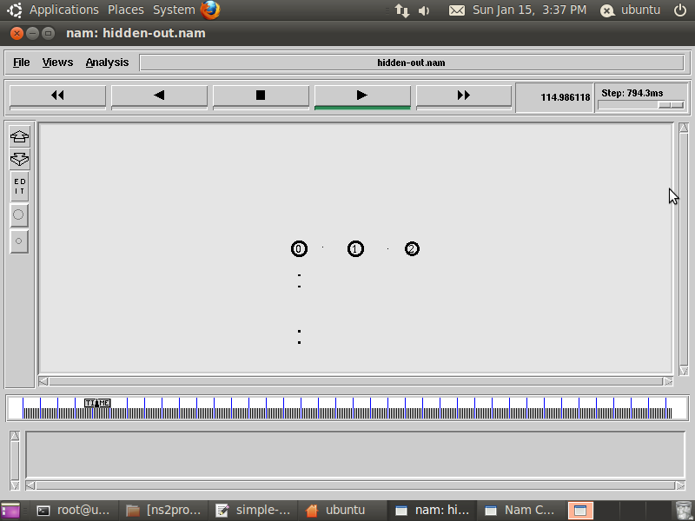

EX. 4 TOPOLOGY AND MOVEMENT GENERATION

AIM:

To write a tcl script to generate movement of nodes of a given wireless topology.

EXPLANATION:

A simple topology of two nodes is created. UDP CBR traffic is created between the nodes n1 and n0. After initial topology move the two nodes towards each other, when the nodes is within the range data transfer is done, when they move away from each other the data packets are dropped.

PROGRAM:

**#Static (Fixed) Topology**

$node_(0) set X_ 50.0

$node_(0) set Y_ 50.0

$node_(0) set Z_ 0.0

$node_(1) set X_ 150.0

$node_(1) set Y_ 50.0

$node_(1) set Z_ 0.0

$node_(2) set X_ 300.0

$node_(2) set Y_ 50.0

$node_(2) set Z_ 0.0

**#Node Movement**

$ns_ at 3.0 "$node_(2) setdest 450 100 50"

$ns_ at 3.0 "$node_(1) setdest 250 100 50"

**#Grid Topology**

set val(rlen) 3

set val(nn) [expr $val(rlen) * $val(rlen)]

set gridspace [expr $val(x) / $val(rlen)]

for {set i 0} {$i < $val(rlen) } {incr i} {

for {set j 0} {$j < $val(rlen) } {incr j} {

set a [expr $j + [expr $i * $val(rlen)]]

$node_($a) set X_ [expr 0.0 + [ expr $i * $gridspace]]

$node_($a) set Y_ [expr 0.0 + [ expr $j * $gridspace]]

$node_($i) set Z_ 0.0

}

}

**#Random Topology**

#To apply random movement we need **setdest** command

#Syntax

setdest –n Nunmber of node –p pause time -M Max_Speed -t total_simulation_time –x x-axisvalue

–y y-axis-value

#Example

setdest -n 20 -p 10 -M 20 -t 100 -x 500 -y 500 >scen-20-20

setdest -n 30 -p 10 -M 20 -t 100 -x 500 -y 500 >scen-30-20

setdest -n 40 -p 10 -M 20 -t 100 -x 500 -y 500 >scen-40-20

OUTPUT:

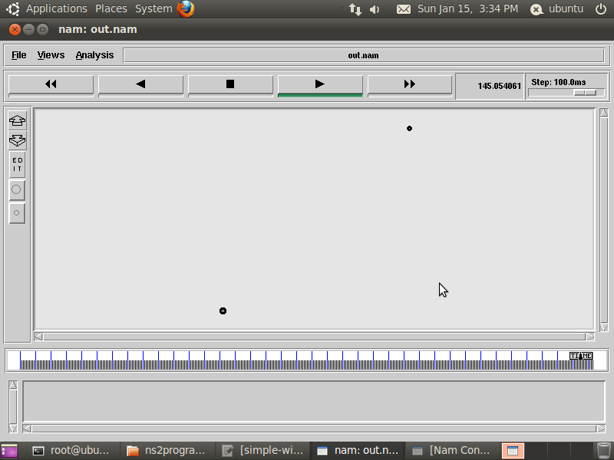

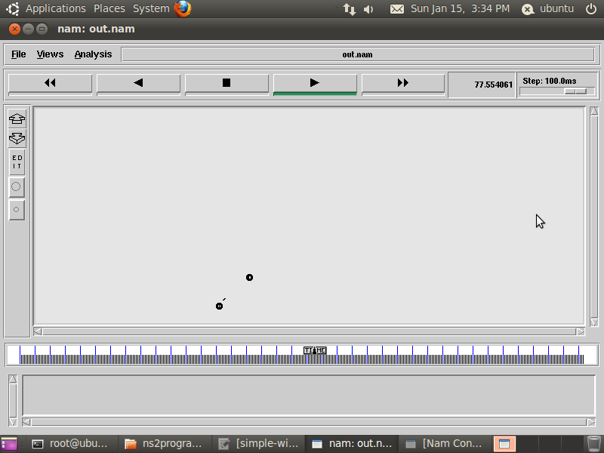

EX.5 ENERGY MODEL

AIM:

To create a energy model for a network topology using NS2.

PROGRAM:

$ns_ node-config -adhocRouting $val(routing) \

-llType LL \

-macType Mac/802_11 \

-ifqType Queue/DropTail/PriQueue \

-ifqLen 100 \

-antType Antenna/OmniAntenna \

-propType Propagation/TwoRayGround \

-phyType Phy/WirelessPhy \

-channelType Channel/WirelessChannel \

**-energyModel EnergyModel \**

**-rxPower 0.3 \**

**-txPower 0.6 \**

**-initialEnergy 10 \**

EX. 6 WIRED CUM WIRELESS

AIM:

To create a wired cum wireless scenario using ns2 simulator.

EXPLANATION:

A wired cum wireless scenario consists of both wired and wireless topology interlinked and data can be sent from a wired node to a wireless node and vice- versa.

PROGRAM:

set val(x) 800

set val(y) 800

set val(ifqlen) 50

set val(tr) wireless.tr

set val(namtr) wireless.nam

set val(nn) 3

set val(adhocRouting) DSDV

set val(stop) 250

set num_wired_nodes 2

set num_bs_nodes 2

set ns_ [new Simulator]

**# set up for hierarchical routing**

$ns_ node-config -addressType hierarchical

AddrParams set domain_num_ **3**

lappend cluster_num **2 1 1**

AddrParams set cluster_num_ $cluster_num

lappend no_of_nodes **1 1 4 1**

AddrParams set nodes_num_ $no_of_nodes

set tracefd [open $val(tr) w]

$ns_ trace-all $tracefd

set namtracefd [open $val(namtr) w]

$ns_ namtrace-all-wireless $namtracefd $val(x) $val(y)

set topo [new Topography]

$topo load_flatgrid $val(x) $val(y)

MIT - Chennai SAT Infosys - CBE 9944219934

7

# god needs to know the number of all wireless interfaces

create-god [expr $val(nn) + $num_bs_nodes]

set W(0) [$ns_ node **0.0.0**]

$W(0) label [$W(0) node-addr]

set W(1) [$ns_ node **0.1.0**]

$W(1) label [$W(1) node-addr]

$ns_ node-config -adhocRouting $val(adhocRouting) \

-llType LL \

-macType Mac/802_11 \

-ifqType Queue/DropTail/PriQueue \

-ifqLen 50 \

-antType Antenna/OmniAntenna \

-propType Propagation/TwoRayGround \

-phyType Phy/WirelessPhy \

-channelType Channel/WirelessChannel \

-topoInstance $topo \

-wiredRouting ON \

-agentTrace ON \

-routerTrace ON \

-macTrace OFF

**#create Base Station**

set BS(0) [$ns_ node **1.0.0**]

set BS(1) [$ns_ node **2.0.0**]

$BS(0) random-motion 0

$BS(1) random-motion 0

**#create links between wired and BS nodes**

$ns_ duplex-link $W(0) $W(1) 5Mb 40ms DropTail

$ns_ duplex-link $W(1) $BS(0) 5Mb 100ms DropTail

$ns_ duplex-link $W(1) $BS(1) 5Mb 50ms DropTail

$ns_ duplex-link-op $W(0) $W(1) orient right

$ns_ duplex-link-op $W(1) $BS(0) orient right-down

$ns_ duplex-link-op $W(1) $BS(1) orient right-up

#configure for mobilenodes

$ns_ node-config -wiredRouting OFF

**#create Mobile Node**

set node_(0) [$ns_ node **1.0.1**]

**#connect Mobile Node with Base Station**

$node_(0) base-station [AddrParams addr2id **1.0.0**]

**#Display Node Address for NAM**

$node_(0) label [$node_(0) node-addr]

set node_(1) [$ns_ node **1.0.2**]

$node_(1) base-station [AddrParams addr2id 1.0.0]

$node_(1) label [$node_(1) node-addr]

set node_(2) [$ns_ node 1.0.3]

$node_(2) base-station [AddrParams addr2id 1.0.0]

$node_(2) label [$node_(2) node-addr]

MIT - Chennai SAT Infosys - CBE 9944219934

8

$BS(0) set X_ 350.0

$BS(0) set Y_ 600.0

$BS(0) set Z_ 0.0

$BS(0) label [$BS(0) node-addr]

$BS(1) set X_ 350.0

$BS(1) set Y_ 300.0

$BS(1) set Z_ 0.0

$BS(1) label [$BS(1) node-addr]

$node_(0) set X_ 350

$node_(0) set Y_ 600

$node_(0) set Z_ 0

$node_(1) set X_ 580

$node_(1) set Y_ 600

$node_(1) set Z_ 0

$node_(2) set X_ 620

$node_(2) set Y_ 600

$node_(2) set Z_ 0

for {set i 0} {$i < $val(nn)} {incr i} {

$ns_ initial_node_pos $node_($i) 20

}

$ns_ at 5.0 "$node_(0) setdest 300 300 50"

$ns_ at 5.0 "$node_(1) setdest 300 400 50"

$ns_ at 5.0 "$node_(2) setdest 300 500 50"

**#create UDP Source**

set udp0 [new Agent/UDP]

$ns_ attach-agent $W(0) $udp0

**#create UDP Destination**

set null0 [new Agent/Null]

$ns_ attach-agent $node_(2) $null0

**#connecting UDP Source & Destination**

$ns_ connect $udp0 $null0

**#create application traffic**

set cbr0 [new Application/Traffic/CBR]

$cbr0 attach-agent $udp0

**#Application start time**

$ns_ at 1.0 "$cbr0 start"

#Application Stop time

$ns_ at 20.0 "$cbr0 stop"

for {set i } {$i < $val(nn) } {incr i} {

$ns_ at $val(stop).0000010 "$node_($i) reset";

}

$ns_ at $val(stop).1 " $ns_ halt"

$ns_ run

EX. 8 ANALYSE THE PERFORMANCE OF A NETWORK USING XGRAPH

AIM:

To analyse the performance of the given network topology using xgraph.

THEORY:

xgraph is a plotting program which can be used to create graphic representations of simulation results. You can create output files in your Tcl scripts, which can be used as data sets for xgraph. Call xgraph to display the results with the command “**xgraph** <**data-file**>”. Below you can see a screenshot of an xgraph window

PROGRAM:

#

# Per-packet tracing from node n0 to node n1

#

# create file for monitoring all packets from n0 to n1

set trace_file [open trace_file.out w]

$ns at 0.0 "$ns trace-queue $n0 $n1 $trace_file"

# SimulationTime

set SimTime 10.0

set old_data 0

#Call the procedure “finish” at the end of simulation

$ns at $SimTime "finish"

proc finish {} {

global ns old_data

$ns flush-trace

# Get data from trace file, put current-time and calculated-throughput in a new file

exec awk {

{

if (($1=="-" && $5=="tcp") || ($1=="-" && $5=="cbr")) {

old_data=old_data + $6

print $2, old_data*8.0/$2/1000000

}

}

} trace_file.out > throughput.data

# Call xgraph plotting program to plot throughput vs time

exec xgraph throughput.data &

exit 0

}

OUTPUT:

